Ideation Phase
Empathize & Discover

Date | 03 October 2026
Team ID | SWTID-2026-6867
Project Name | Streamlining IT Procurement: Automating Standard Laptop Orders with Flow Designer
Maximum Marks | 4 Marks

Empathy Map Canvas:
An empathy map is a simple visual tool used to understand the experiences, needs, behaviours, and challenges of users interacting with a system. For the Streamlining IT Procurement: Automating Standard Laptop Orders with Flow Designer project, the empathy map helps us understand the experience of an employee requesting a standard laptop through the IT procurement process. It helps the project team identify what the employee thinks and feels, hears, sees, says and does while requesting and waiting for the laptop. Understanding these experiences helps identify problems such as manual approval activities, configuration delays, limited status visibility, and uncertainty about when the laptop will be ready. These insights support the development of an automated ServiceNow solution using Flow Designer to create and assign laptop configuration tasks after approval, helping provide a smoother and more efficient procurement experience.

Example:
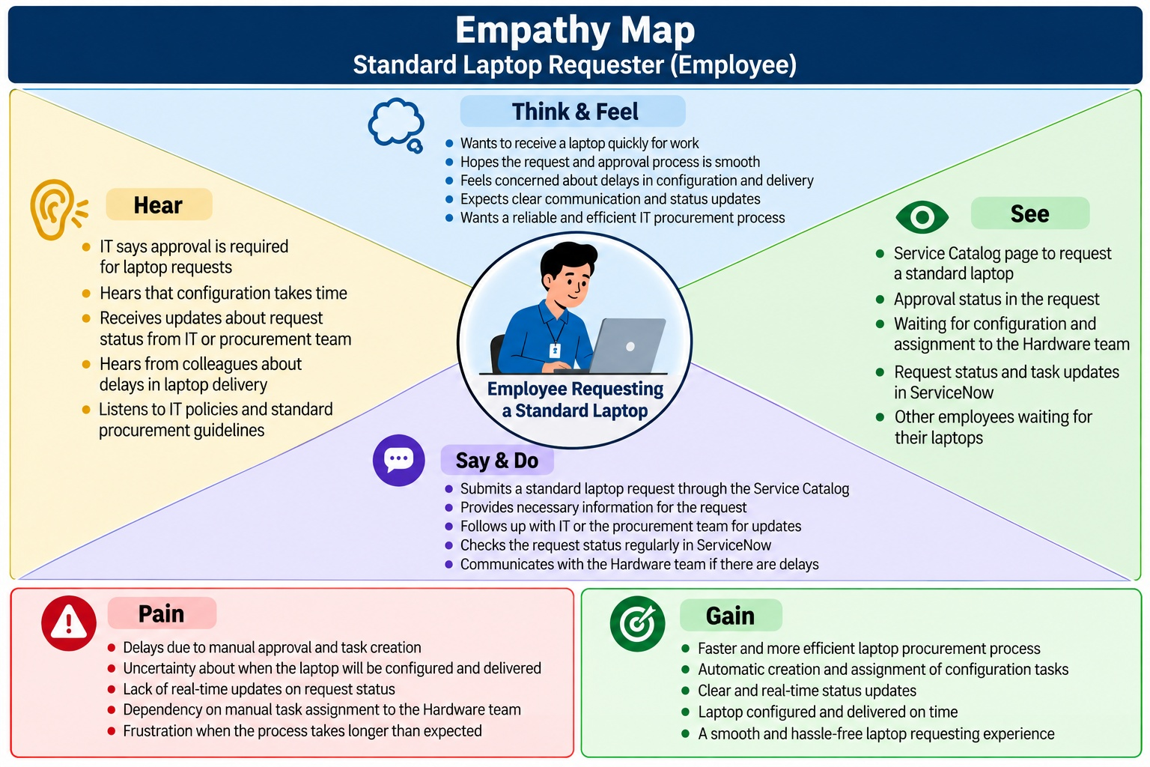
Reference: https://www.mural.co/templates/empathy-map-canvas

Example: IT Hardware Request & Delivery Experience
